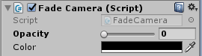  
“Fade Camera” script has 2 functions: FadeOut – blackout, FadeIn – oppositely.

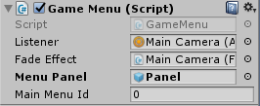  
Menu Panel - The panel, which is called when the pause.  
Main Menu Id - Main menu scene index. 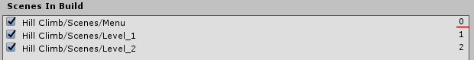

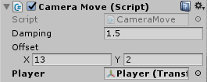  
Player – Target.  
Offset – The offset of the camera from the target. Automatic calculation of the offset:  
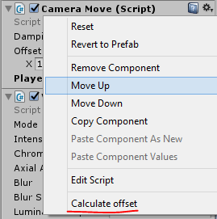

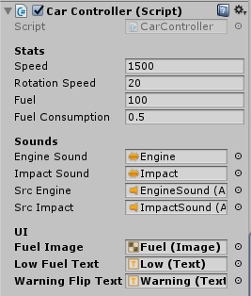  
Speed – speed of movement.  
Rotation Speed - rotation velocity.

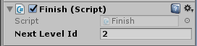  
Next Level Id - the index of the next level.  
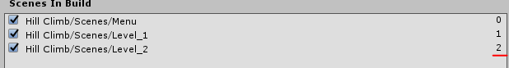  
How to reset save?  
